Use Case 1: Write a new note and save

Step 1. User opens the app.

Step 2. The app shows the UI.

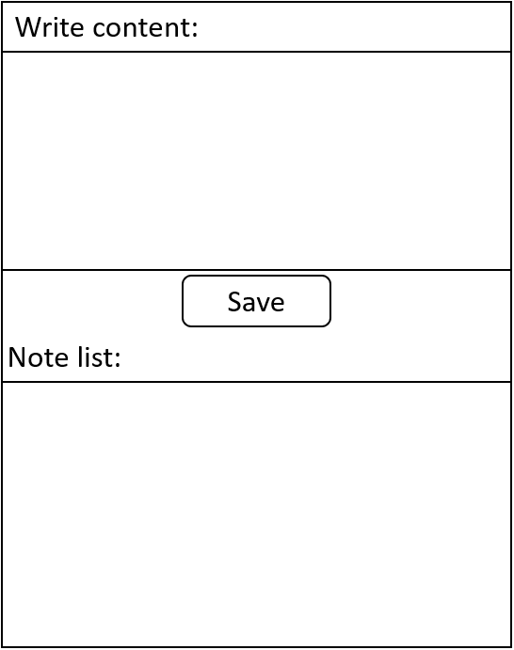

Step 3. User enters the content and click “Save” button.

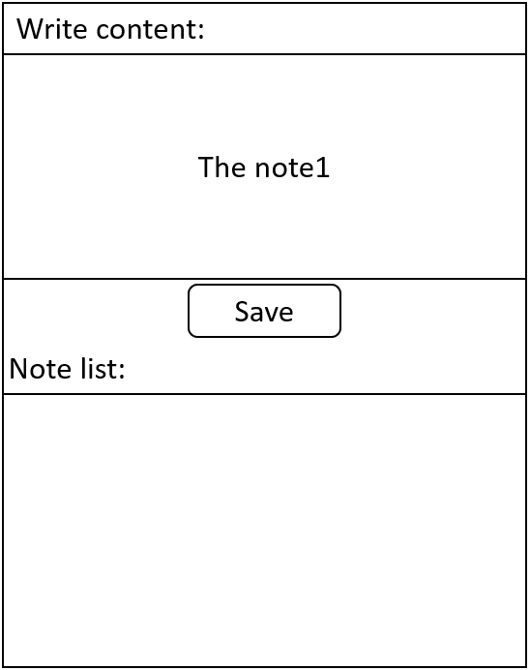

Step 4. The app saves the note and shows it in the note list.

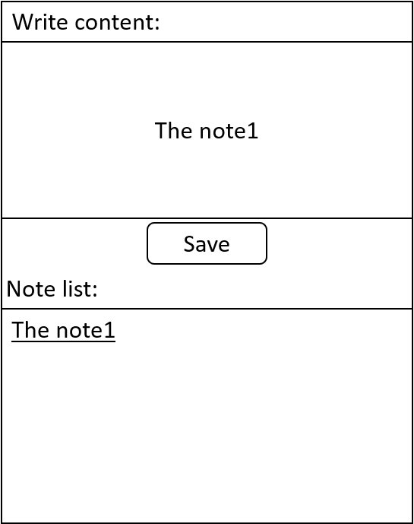

Use Case 2: Edit an existing note

Step 1. The app shows the note list.

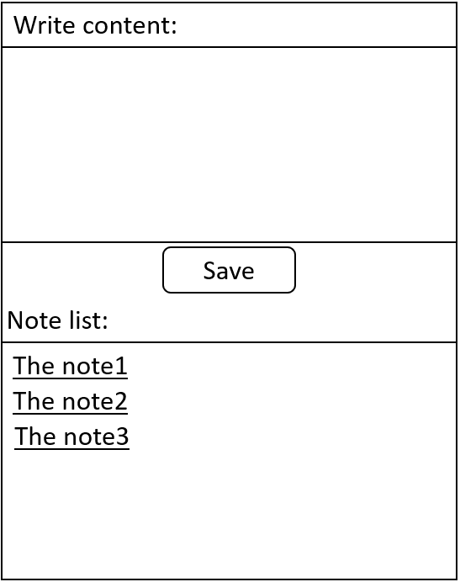

Step 3. User click a note and edit it.

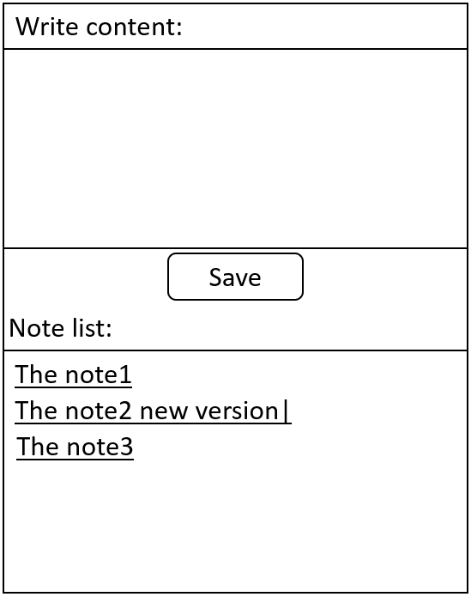

Step 4. The app automatically saves the note and shows the new note list.

